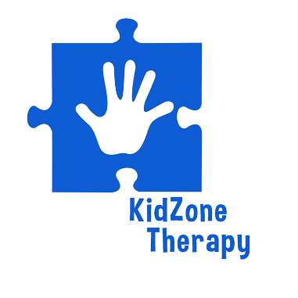

What is Occupational Therapy for children?
“Occupational therapy? But my child doesn’t have a job or go to work?” A child’s main occupation is play. OT helps children succeed in important areas of their lives. This includes helping children build the skills required for essential daily activities such as brushing their teeth, writing their name, or playing with friends.
OT’s try to determine where delays or limitations are coming from, especially in the areas of fine motor skills, cognitive skills, social development, and establishing self-care routines. Together, these skills lead to children being able to grow into healthy, well-functioning adults. Occupational therapist help any age beginning with birth all the way to 18 years of age.

Children see occupational therapists for a variety of reasons including:
- Delays in fine motor skills
- Help developing visual motor skills – tracking an object, hand-eye coordination
- Cognitive delays including problem-solving skills, memory, and attention
- Children with sensory integration issues
- Delays in play and social interaction skills
- Help with learning basic self-care tasks, such as getting dressed
- Gross motor deficits such as jumping, bouncing, running

Diagnosis include: Cerebral Palsy, Autism, Down Syndrome, Muscular Dystrophy and associated disorders, ADHD, ADD, Apraxia, Spina Bifida, Juvenile Rheumatoid Arthritis, Arthrogyposis, Cardio-Pulmonary Disorders, Cystic Fibrosis, Cancer, and Traumatic Brain Injury and many more.

What is Physical Therapy for children?

The role of the pediatric physical therapist is to evaluate and provide treatment for delays in motor skills by developing the strength and range of motion that children need to move through their environment easily and effectively.
They are assessing areas of:
- Flexibility
- Strength
- Posture
- Gait
- Sensory processing
- Balance
- Coordination and skill
What is different between regular PT and pediatric PT?

Children often don’t understand why they are in therapy. Play, family involvement, and one-on-one care are important when providing care to the children. Fun and motivational factors are incorporated into functional activities to make therapy enjoyable for the child. Collaboration of care includes recommending and training in orthotics, prosthetics, adaptive equipment, custom wheelchair seating systems and adaptive technology.

Diagnosis include: Cerebral Palsy, Autism, Down Syndrome, Muscular Dystrophy and associated disorders, Spina Bifida, Juvenile Rheumatoid Arthritis, Arthrogyposis, Cardio-PulmonaryDisorders, Cystic Fibrosis, Cancer, and Traumatic Brain Injury.

